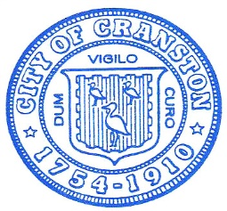

Cranston City Hall

869 Park Avenue

Cranston, RI 02910

Kenneth J. Hopkins

Mayor

January 6, 2021

Cranston Mayor Kenneth J. Hopkins tonight issued the following statement:

I want to express my extreme personal outrage and tremendous concern over the protests and rioting being witnessed before the eyes of the world in Washington, DC.

This is not the America I know or we grew up in. This is a time when we should be observing and celebrating the peaceful transfers of power in Washington, and in many state houses and local communities. Instead the world watches as disturbed protesters and uncontrolled mobsters disrupt the national certification of a new president’s election. They have endangered our elected representatives, themselves, law enforcement and National Guard members.

There can never be any justification for this type of dangerous and disrespectful activity that threatens the cradle of our democracy and our governmental leaders. Shame on anyone who incited or encouraged this lawless behavior.

These are not peaceful protesters. They are thugs who show no respect for our government and its institutions. The federal government should do whatever is necessary to regain control of the federal buildings and resume the timely certification of President-Elect Biden’s election.

We need to show the world that in the United States nothing stops our elections, breaks our national spirit or prevents the rightful upholding of the law.

As a long time teacher, I know moments like this this can someday become a teachable moment in our history. That’s for tomorrow. Today we need to do whatever is necessary to quell this unwarranted disturbance, secure our capitol building and regain control from this chaotic scene.

Media Contact:

Anthony C. Moretti

Director of Administration

401-742-9866 (Cell)